**US Housing Market Analysis & Insights: 2008 – 2019**

**Key Findings**

**How have the average median house sales and foreclosure resale rates trended since 2008?**

Average median house sales have steadily increase year over year since 2011 and 2012 (*see Exhibit 1*) and foreclosure resale rates have continued to decline since 2011 and 2012, too (*see Exhibit 2*). What the increase in average median house sales compounded with the decline of foreclosure resale rates indicates is the national housing market has been rebounding since the housing market collapse in 2008.

Exhibit 1: Seasonally Adjusted Median Sales Prices Over Time

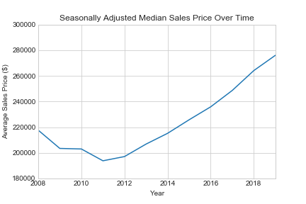

Exhibit 2: Percentage of Foreclosure Resales

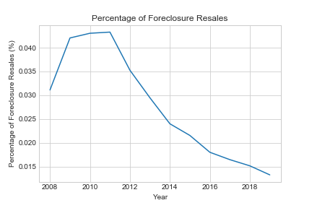

**What are the top five states with the highest increases and highest decrease in median house prices since 2008?**

For our analysis, we factored in all fifty states as well as included the District of Columbia (DC). Here are the top five states that experienced the highest increases in median sales prices since 2008: DC, California, Colorado, Washington, and Massachusetts (*see Exhibit 3)*. Interestingly, housing prices in these five areas began increasing in value consistently starting around 2011 and 2012 (*see Exhibit 4)*.

Exhibit 3: States with the Largest Increases in Housing Prices

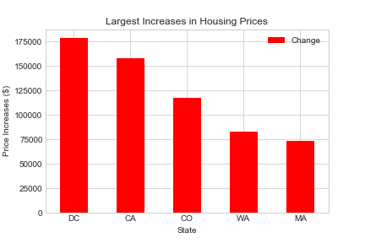

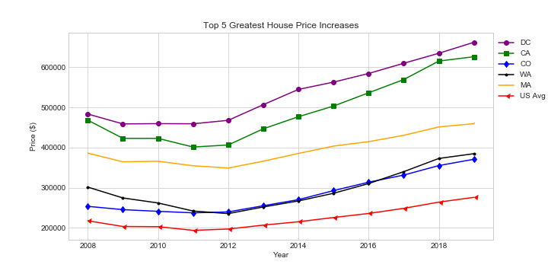Exhibit 4: Top 5 Greatest House Price Increases 2008 - 2019

The following five states experienced the top five median sales price decreases for houses since 2008: Connecticut, New Jersey, Maryland, New Mexico, and West Virginia (*see Exhibit 5)*. States like Connecticut, New Jersey, and Maryland appeared to have been consistent with the national average around 2011 and 2012; however, New Mexico and West Virginia are different. Unlike the other states analyzed, New Mexico and West Virginia only started seeing housing prices increase starting 2015 *(see Exhibit 6)*.

Exhibit 5: States with the Largest Decreases in Housing Prices

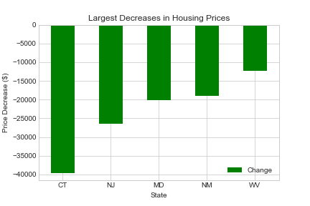

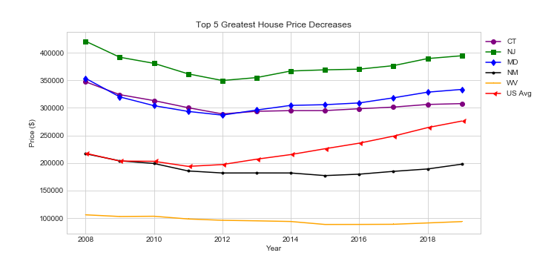Exhibit 6: Top 5 Greatest House Price Decreases 2008 - 2019

**What consumer/market variables affected median sales prices for homes since 2008?**

To see what may be affecting the median sales prices for houses, we ran a multiple regression of several consumer/market variables against the average median sales prices for the top five states with the highest increase and highest decrease in housing prices. The variables we looked for correlation with median sales prices include the following: Zillow Home Value Index, Monthly Home Sales, Foreclosure Resales, Divorce Rates, Unemployment Rates, Student Loan Debt, Total Debt, and Median Household Income. Each state’s median sales prices for houses appeared to have different correlations with the variables we analyzed, which illustrates no one state’s median sales prices for homes are affected by the same variables. The following plots show the top three variables correlated with the median sales prices for homes in DC *(see Exhibit 7)* and Connecticut *(see Exhibit 8)*:

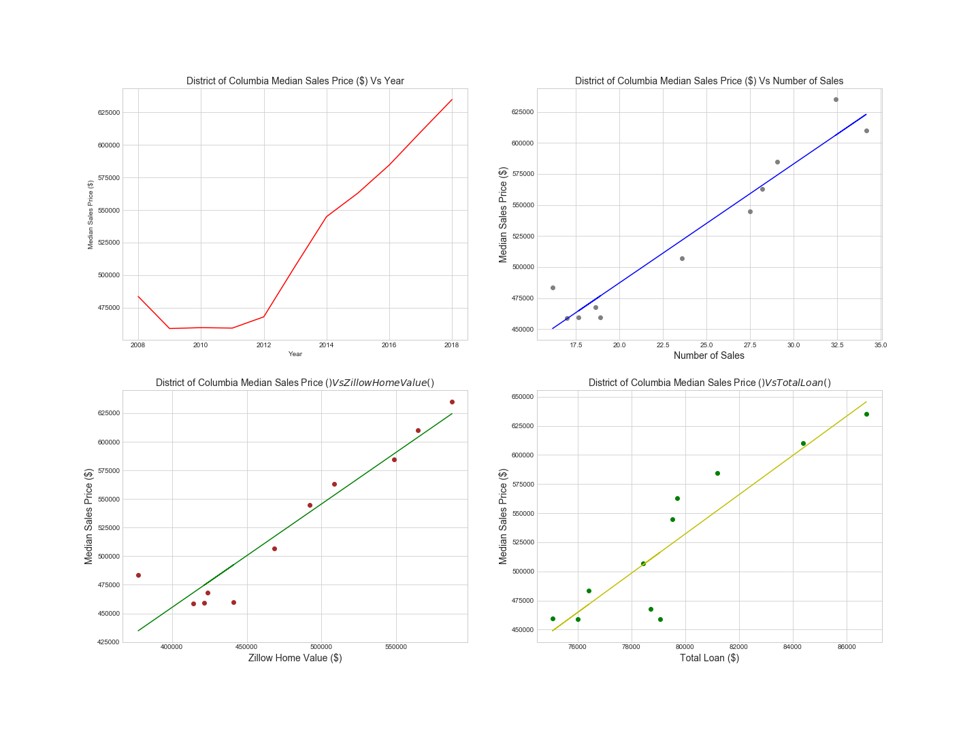Exhibit 7: DC Median Sales Price Variable Correlations

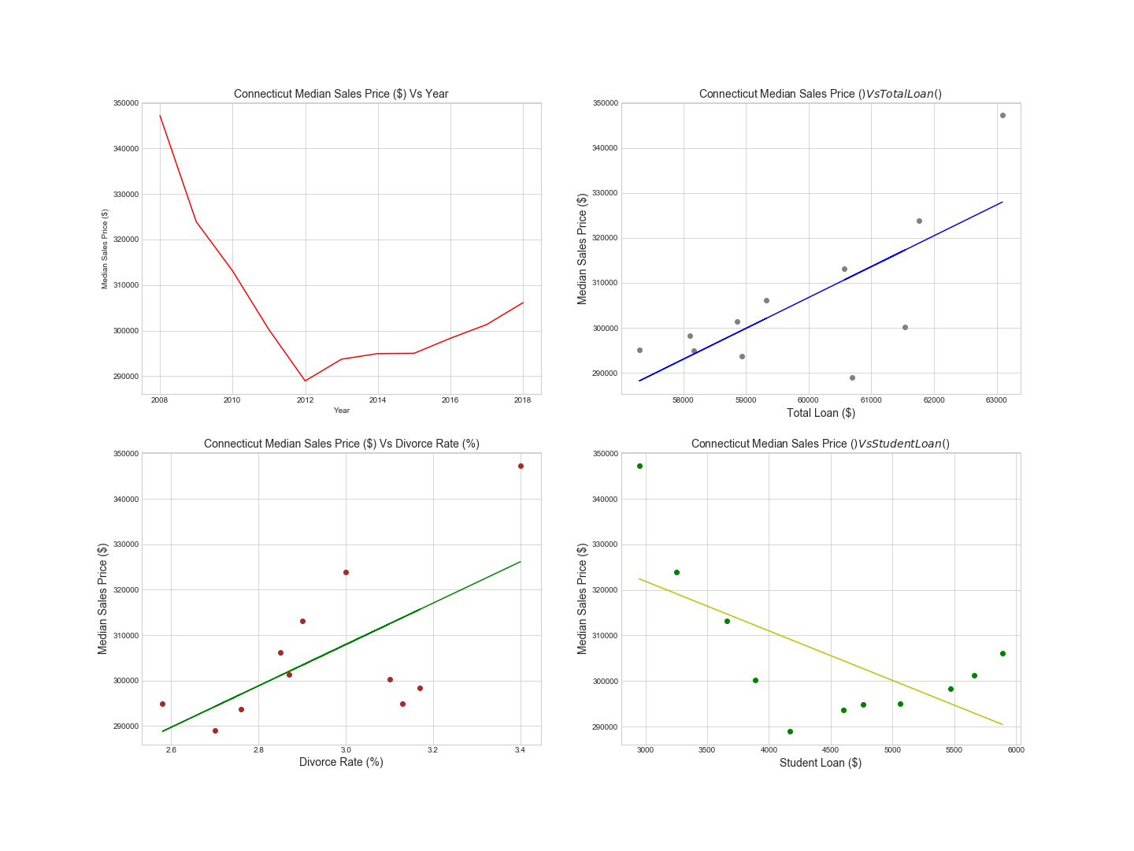Exhibit 8: Connecticut Median Sales Price Variable Correlations

**Based on the results of Question 3, what may future median sales prices look like?**

Analysis/trends